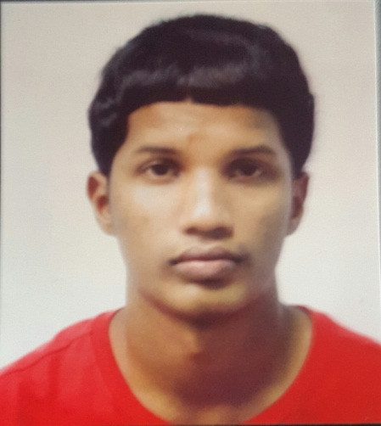

BRADLEY BAKSH

Objective: I am very motivated, energetic and ambitious individual who is willing to work hard and honestly. I am open to expanding my knowledge and gaining as much experience as possible. Also, I am goal oriented and can work well with others in getting tasks done efficiently.

Below is my resume and I will be eagerly awaiting a positive response. Thank you

Date of Birth: 19th, February, 1995

Address: Mahabir Avenue Charlieville chaguanas

Contact Number: 1868 317-5114

Qualifications

Integrated Science

Physical Education

Mechanical Engineering Technology

Rewriting Mathematics

English Language

Rewriting Mathematics

Level 1 certificate Mechanical Engineering Technology

Education: Mayaro Secondary School (2009- 2014)

Work Experience: Sales Clerk at Fair and Square Chaguanas (2014) (Part Time Job)

References: Renee Dial (Biology Teacher) Contact Number: 1868 630-4506

Zenda Farouse (Price Mart Supervisor) Contact Number: 1868 798-8467

Position Appling For: Sales Clerk